Analyzing Ramcharitmanas Using Computational Methods: A Study of Sentiment, Themes, and Character Interactions

Abstract

One of the most renowned classical epics in Indian scriptures is sri ramcharitmanas which was composed in the 16th century by the poet-saint Goswami Tulsidas. It is honoured as a treasure of Bhakti literature which restates the story of Ramayana in Awadhi language ( a dialect of hindi ).
Existing studies primarily focus on translation or literary interpretation of ancient scriptures. Also, there is limited work on languages like Awadhi and contextually rich texts like sri ramcharitmanas.In this research, the focus is to uncover the emotional,thematic, narrative intricacies of the text. Furthermore, the emotional layers of leading characters like Rama, Sita, Laksamana, Hanuman and Ravana across each kaand (segment) is analysed using sentiment analysis. The narrative analysis shows that the mention of Rama exceeds that of any other protagnist. The thematic analysis reveal the fundamental themes of Dharma, Victory and spiritual development. By using network analysis, the complexity of character interactions and social dynamics is decoded. This study demonstrates how computational techniques can provide novel structural insights into classical Indian epics and provide newer perspectives on sri ramcharitmanas while also enhancing our understanding of the prominent epic and bridging the gap between traditional wisdom and modern data-driven analysis.

Introduction

Sri Ramcharitmanas, written in the 16th century by the great poet and saint Goswami Tulsidas, is renowned for its profound philosophical ideas and spiritual wisdom. It is a pillar Hindu literature and is a beautiful representation of Indian culture. The epic is a source of moral and ethical wisdom for millions of people all over the world.
It was written in Awadhi — a low resource Asian language primarily spoken in the Awadh region of Uttar Pradesh, India. The name Awadh is etymologically connected to Ayodhya, the birthplace of Lord Rama. Despite having native speakers and culturally significant in Indian literature, Awadhi is severely under-represented in digital linguistic resources.
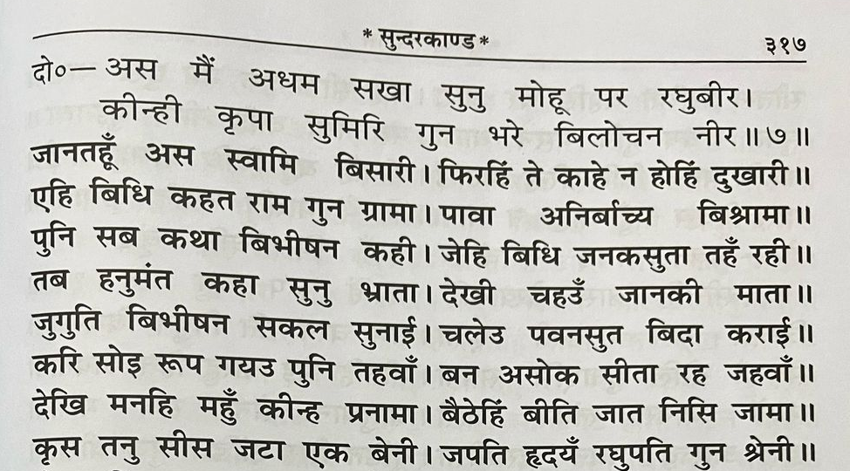
Figure 1: Excerpt from Sri Ramcharitramanas
Traditional methods have been used previously to examine the spiritual depths of Sri Ramcharitmanas. In this research project, we utilize computational methods and sentiment analysis on the holy book. Analyzing the intricate layers of emotion, sentiment, and narrative dynamics of the premise and the characters is the focus of this manuscript.
Our research aims to illuminate Sri Ramcharitmanas by employing novel methods and providing reflective insights into its teachings and narrative brilliance and thus expanding our understanding of this acclaimed scripture.
Table 1: Key Attributes

Attributes  Size in Bytes | Value  1,571,712 | Remarks  After Processing (eg. Removing comments)
Number of Words | 269616 | Using NLTK
Number of unique words | 25225 | Using NLTK
Number of Sentences | 10401 | Using NLTK
Number of Kaands | 7 | Total numbers of sections
Number of Chapters | 217 | Total number of chapters
Number of Characters | 80 | Appearing at least 10 times in the text

Literature Review

Over the years many scholars have worked on novel researches to uncover hidden patterns in literary works which lead to great advancements in the computational literature analysis domain. On the basis of such studies, this research aims to find the significance of computational methods in the breakdown of Sri Ramcharitmanas.
The social network analysis of "Alice in Wonderland" by Agarwal et al. (2012) provides a constructive outline for character interactions and relationships within a narrative. We look for the fundamental themes and motivations that drive the narrative by applying similar network analysis techniques to Sri Ramcharitmanas so as to understand the social dynamics of characters in the epic. In a correlative methodology, Elson et al. (2010) displayed the capability of computational strategies to uncover underlying designs inside texts. Saif M Mohammad and Peter D Turney's work on vocabulary can offer insight on the subject’s emotion and opinion. Academicians can gain a deeper comprehension of the narrative complexities of the text by introducing network analysis, sentiment analysis, and other such tools which also help to uncover new layers of meaning, identify thematic patterns, and gain a deeper understanding of the themes. The reviewed literature provides an outline for exploring the social, emotional, philosophical and thematic dimensions of the epic through a newer lens. By utilizing the experiences and techniques introduced in these examinations, experts can look beyond the conventional interpretation of Sri Ramcharitmanas
The English translation of Ramcharitmanas which can be found on the Gita Press website (https://archive.org/details/RamcharitmanasGitapressEnglish/mode/1up) has been used in our research. This interpretation was distributed in solidified structure alongside the first Nagari script in 1968 and before that it was distributed in a magazine called Kalyana-Kalpataru in three portions. This has 7 "Kaands" or chapters and each "Kaand" has numerous parts.

Methodology

This section lays a framework of the methods and techniques utilized in our study to achieve the objectives outlined in the paper. We have utilized specialized libraries and tools such as NLTK to streamline various aspects of text processing, analysis, and visualization. Our approach for comprehensive analysis is presented as follows:
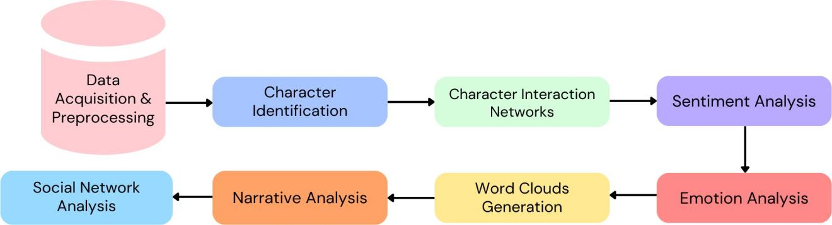

Figure 3: Flowchart of Methodology

  - Data Acquisition and Pre-Processing

In the initial phase the translated text of Ramcharitmanas is acquired from a reliable source ensuring the authenticity of the text corpus.
- The irrelevant elements such as metadata, page numbers, chapter summaries, and unnecessary symbols are removed ensuring that only the vital text is retained for analysis.
- Tokenization is done to break down the text into tokens and normalization to standardize spelling, case, and punctuation.
- Common Stop-words like "and," "the," and "is" are removed using NLTK's built-in stopwords corpus. Also the words are lemmatized to their root forms to enhance precision and reduce redundancy.

  - Character Identification

Here the aim is to precisely document the protagonists within the text. Proper nouns denote names of characters, locations, and other significant entities thus POS tagging is used. A comprehensive roster of characters from the Ramayana which are obtained from credible sources serve as a reference point for our study. Also a thesaurus of alternative names for the leading characters is integrated. For example, the name "Sita" may be synonymous with "Siya", "Janaki", or "Maithili." This step streamlines the consolidation of synonymous names into a unified character entity.
A frequency threshold is applied to retain only names that surpass a predetermined minimum frequency. This ensures that only the most significant characters are retained in the pre-processed text. In our text, this process led to the identification of 80 characters.
Identified characters undergo a top percentage filtering for further refinement by retaining only those within the top 30 percent of character mentions in each "kaand" (chapter) of the text. Fine-tuning occurs at both the individual "kaand" level and across the entire text, which ensures a balanced portrayal of characters in the narrative, with a focus on the protagonists.

  - Analysis of Character Interaction Networks

We analyze the complexity of relationships between characters. This method helps to uncover the dynamic relationship among characters, their roles, and their significance in the narrative. The analysis of character interaction networks mainly serves two crucial purposes:
- Identification of key characters which highlights the top 20 characters in each Kaand that are essential to the narrative.
- Exploration of relationships which looks into the nature and frequency of interactions among these characters and reveals alliances, conflicts, and dependencies.
The methodology for analyzing character interaction networks consists of these steps:
- Character interaction networks are built using Python libraries like NetworkX and Graph-tool where characters are represented as nodes and interactions as edges.
- The edges are assigned with weights based on the interaction frequency and natural language processing tools such as spaCy and NLTK for extracting relevant interactions are used.
- Visual representations of the interaction network are created using Python visualization libraries like Matplotlib and Seaborn.

  - Sentiment Analysis of Main Characters Across All the Kaands

This step involves conducting sentiment analysis to understand the emotional range specifically focusing on our main characters - Ram, Sita, Lakshman, Hanuman, and Ravan - across all the kaands of Ramcharitmanas.
- Once the leading characters are identified, each kaand is parsed to identify the frequencies of occurrences of the main characters. The frequencies are calculated by using NLP techniques such as Sentiment Intensity Analyzer and named entity recognition.
- Sentiment analysis is performed to calculate emotional polarity (positive, negative, or neutral) and a compound score.
- Next, a lexicon-based approach is used to assign sentiment scores to words or phrases. These scores are combined to determine the overall sentiment expressed in the texts.
- A sentiment analysis is conducted by taking the contextual information into account from the surrounding text.
- Visualizations are carried out on the outcomes of the analysis to offer insights into the emotions of the main characters across different kaands.

  - Implementing topic modeling, Generating Word Clouds and Narrative analysis

Topic modeling is applied to uncover various themes within the text. The number of topics was set to 5 and then topic modeling was conducted using Latent Dirichlet Allocation (LDA) which identifies topics by allocating words iteratively to topics and assessing the probability of each word belonging to a specific topic. The most probable words for each topic were determined with their corresponding probability for each document. Bar plots are generated to visually represent the topics and their most significant words, offering a clearer insight into the thematic content of Ramcharitmanas.

Word clouds represent words with the highest frequency which are created to interpret the sentiment prevalent in all the Kaands. Our focus was on determining the top 20 frequently occurring words across all Kaands to unveil recurring themes and subjects.

A narrative analysis is conducted to identify the crucial elements and themes within each kaand which includes the identification of themes like "Dharma" and "Victory" as well as the frequency of references to main characters and specific narrative events. The outcomes of the narrative analysis are visually represented using line plot to gain a deeper understanding of the narrative structure and character progressions throughout the text.

Result Analysis

- Narrative Analysis

This narrative analysis provides a refined understanding of the underlying themes and character interactions throughout the text.
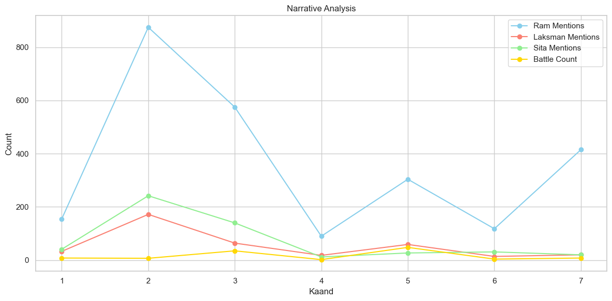
Figure 5: Graph of Narrative Analysis

It represents key figures like Rama, Sita, and Laksman throughout the epic. Rama's mention exceeds that of any other protagonist. Even the battles emphasize the central role of Rama and his presence in the narrative. The visual representation shows that Rama's prominence peaks in the second Kaand. Mentions of Sita and Laksman peak during the second Kaand and then gradually diminish moving forward. Depiction of battles gains importance in the fifth Kaand, aligning with the thematic focus on Victory. During this phase mentions of Laksman and the portrayal of battles overshadow the mentions of Sita in significance which indicates a shift in the emphasis of the narrative.

  - Word Clouds

Word clouds provide insights into the characters' roles and relationships in the narrative.
- Lord Rama's cloud highlights courage and righteousness, portraying him as a leader.
- Laksmana's cloud emphasizes loyalty, kindness and his unwavering support for Rama.
- Sita's cloud indicates her compassion, generosity and forgiveness.
- Hanuman's cloud exemplifies wisdom, heroism and his devotion to Lord Rama.
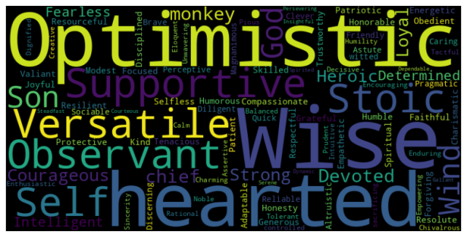
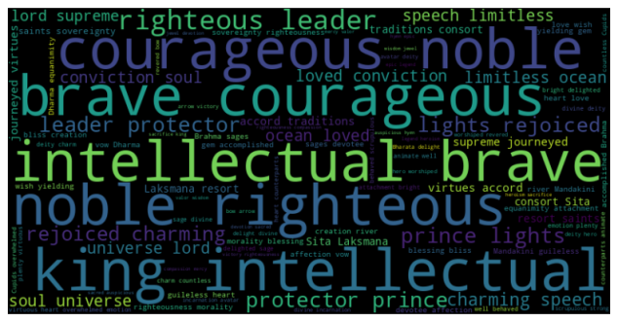
- Ravana is characterized by negativity such as ruthlessness, maliciousness and aggression.
Figure 6: Word Cloud of Rama Figure 7: Word Cloud of Hanuman
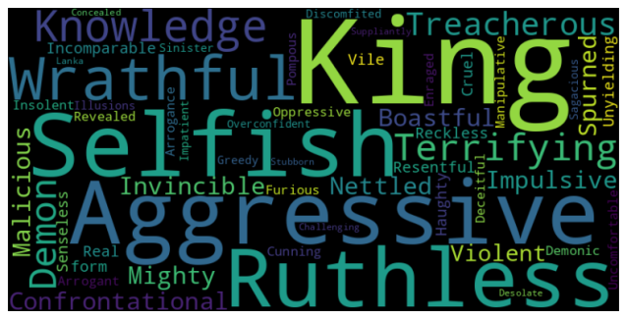
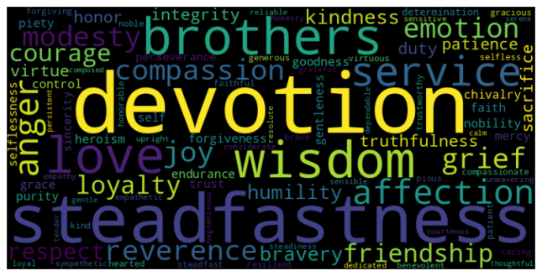
Figure 8: Word Cloud of Laksmana Figure 9: Word Cloud of Ravana

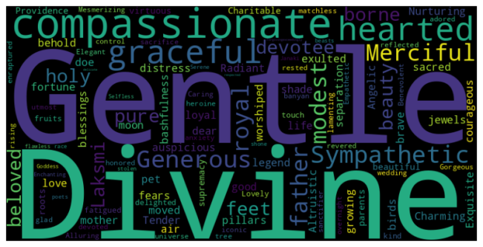
Figure 10: Word Cloud of Sita

  - Word Frequencies

The study of the words that often repeat in the different parts of the Ramayana offers thematic descriptions, inherent motifs, characterizations, and ideas that guide every part of the epic.
- In the Baal Kaand, terms like “lord”, "rama," "sri" and "king" highlight the divinity of Lord Rama and the just rule of his father, King Dashratha. “Heart” being used so frequently indicates the emotional aspect of the story and how the characters are driven by devotion. There are also mentions of God who bless Dashratha with sons. Lord Shiva’s role is also emphasized as stringing his divine bow is the challenge presented to win Sita’s hand in marriage.

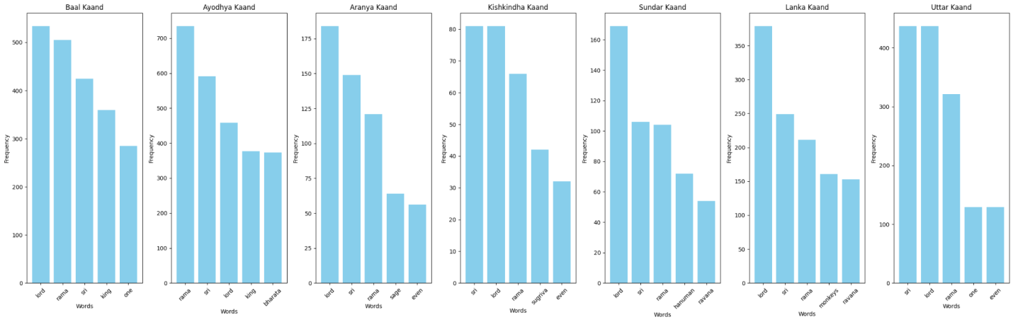
Figure 11: Comparative Graph of Word Frequencies of Top 5 Words

- The Ayodhya Kaand emphasizes duty, loyalty, and love through terms like "Sri" "Bharata" and "Sita". Bharata’s role in Ramcharitmanas is of the ideal brother. Particularly, in this kaand, he goes through an emotional journey of learning about his father’s demise, exile of Lord Rama and assuming a symbolic rule over Ayodhya. Sita becomes the epitome of strength as she makes the choice of rejecting material comforts and accompanies her husband to exile.
- In the Aranya Kaand, there is a high frequency of the word “sage”. The main role of the sages was to impart wisdom and request Lord Rama to vanquish demons, solidifying his purpose as a protector.
- The Kishkindha Kaand covers the story of Sugriva wherein Lord Rama helps him get back his rightful throne and then guides him back to “dharma” to assist in finding Sita.
- Hanuman is the protagonist of Sundar Kaand. He flies across the ocean to find Sita, has an emotional conversation with her and then comes the legendary tale of burning down Lanka. He inspired by being an ideal devotee and a powerful warrior.
- The high mentions of “monkeys” in the Lanka Kaand reflect their unity and dedication towards Lord Rama. This kaand is the climax of the story and consists of the valiant battles which are fought strategically.

  - Character Interaction Network

The character interaction network is a graphical illustration that offers insights into the dynamics of the epic. The top 20 characters of Ramcharitmanas are selected on the basis of their prevalent interactions that showcase their narrative significance. To conduct a computational analysis, it is essential to understand the complexity of relationships that shape the narrative.
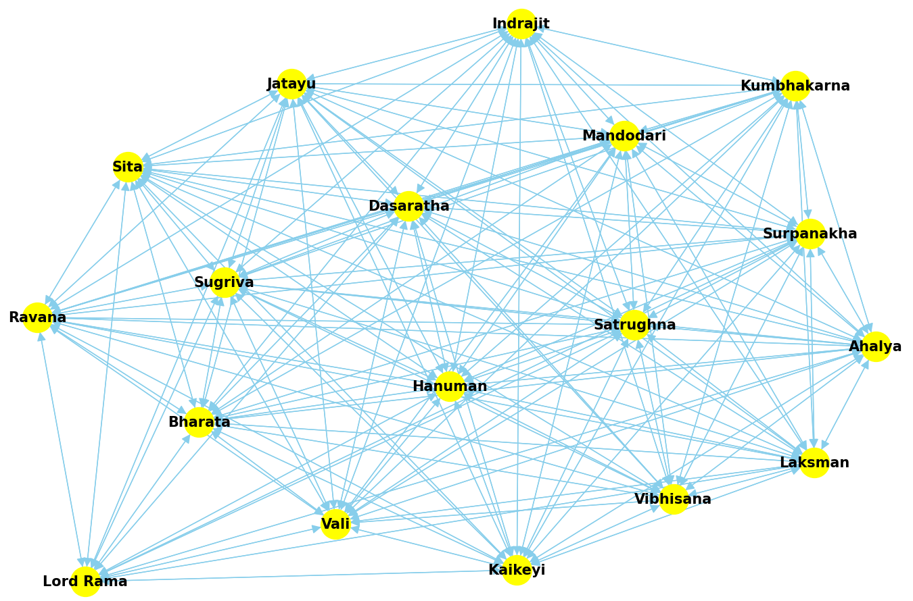
Figure 12: Character Interaction Network of Top Characters
  - Sentiment Analysis of Characters

The sentiment analysis shows diverse emotional patterns and trajectories of the characters.
- Lord Rama's sentiment is generally positive throughout the kaands. However, he displays anger as a few points in the story such as when Sugriva neglected his duty to help find Sita, when the Ocean God did not respond to his prayers for three days he became furious and during the final war against Ravana Lord Rama channels his fury into a Brahmastra (celestial weapon of mass destruction).
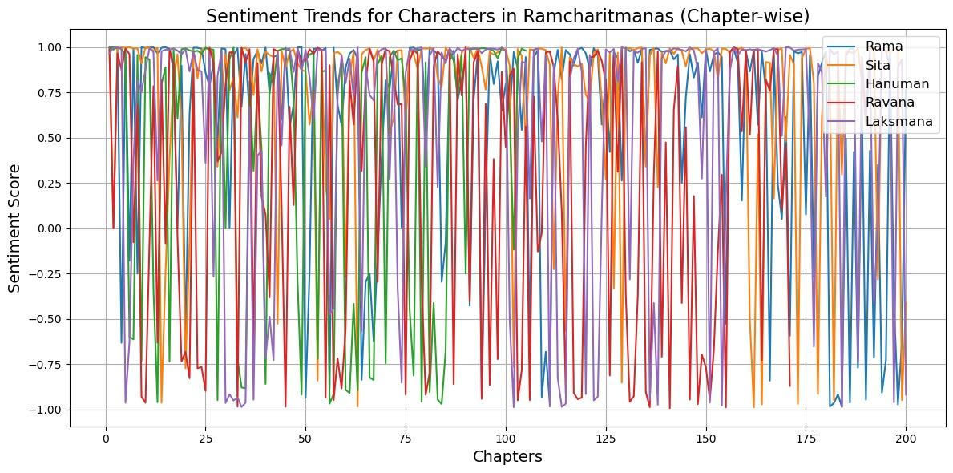
Figure 13: Sentiment Trends of Top Characters

- Sita's sentiment remains consistently positive but she experienced fear and sorrow at the event of her abduction.
- Ravana is consistently negative. However, the sentiment shifts to neutral towards the end of his character arc. This happens before his demise where he recognizes Rama’s divine power and imparts some wisdom showing that he was a great scholar.
- Hanuman's sentiment is mostly positive, with temporary negative shifts in the sentiment when he burns Lanka, mocks Ravana in court and then during the final war.
- Laksman is a character of complex emotions and strong opinions. His anger is rooted in his devotion for his brother and dharma. His sentiment is generally neutral but it swings to negative at various occasions. Most notable mentions are: his fury at Sage Parshuram when Rama breaks Lord Shiva’s bow, his anger at Queen Kaikeyi as she demanded Rama’s exile, his defensiveness when Bhartha visits the trio at Chitrakoot, his protectiveness for Rama against Surpanakha.

  - Emotion Analysis

The emotional analysis of characters in the text showcases many interesting perspectives about their psychological status and their contribution to the narrative. Bar graphs depict sentiment scores for each character across kaands.
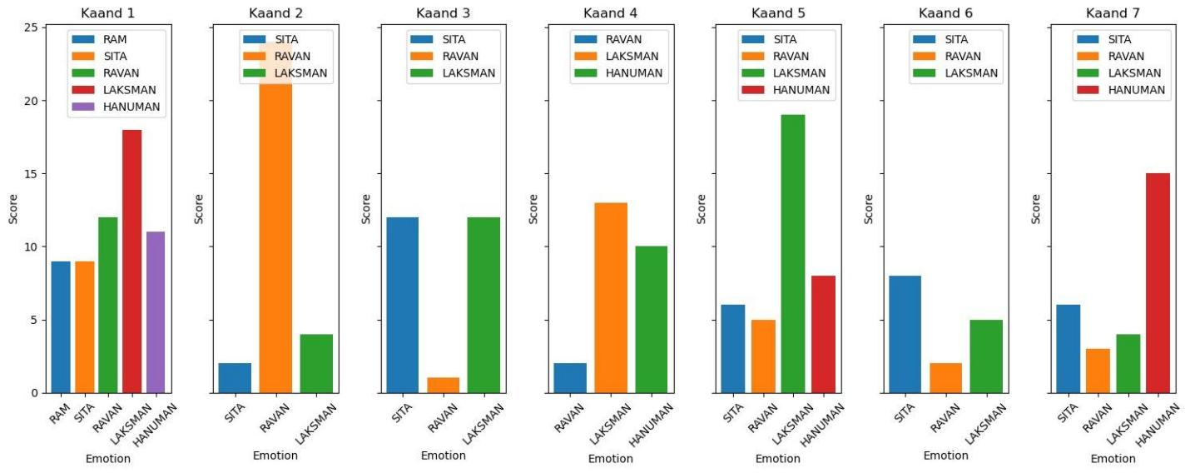
Figure 15: Comparative Graph of Emotional Analysis

- Laksman's consistently high emotional scores reveal his strong opinions, his intolerance towards adharma, and his unwavering loyalty to his brother.
- Ravan's fluctuating scores depict the complexity and internal conflicts as the antagonist.
- Sita has a very interesting emotional journey throughout. She goes from being a gentle princess to the joy of married life and then experiences the exile and abduction where she has displays devastation but resilience.
- Hanuman's emotional states his spiritual devotion towards Rama and his determination towards finding Sita.

Conclusion
This study presents the computational analysis of sri ramcharitmanas and explored the structural, thematic and linguistic patterns to offer an innovative approach to understand the scripture. The results substantiate clear thematic segmentation between different themes across the kaands (segments) and the shifts in the emotional intensity for characters like sita from a gentle princess to experiences like fear and devastation. The word clouds provide insights into the temperament of different characters, for example Lord Rama cloud highlights courage and righteousness which portrays him as a leader whereas Lakshmana's cloud shows loyalty and his wavering support for Lord Rama. The character interaction network illustrates the complexity of relationships between characters. These findings suggest that computational methods can be efficiently applied to uncover the semantic depths of literatures like sri ramcharitmanas. This research contributes to the intersection of computational analysis and classical Indian literary studies and providing insights into their teachings and narrative brilliance. Future works may extend this work through transformer-based contextual analysis, and cross-textual comparative analysis.

References

Agarwal, Apoorv et al. (2012). “Social Network Analysis of Alice in Wonderland”. Proceedings of the NAACL-HLT 2012 Workshop on Computational Linguistics for Literature, pp. 88–96.

Elson, David, Nicholas Dames, and Kathleen Mckeown (2010). “Extracting Social Networks from Literary Fiction”. Proceedings of the 48th Annual Meeting of the Association for Computational Linguistics, pp. 138–147.

Kang, H, S J Yoo, and D Han (2012). “Senti-lexicon and an improved naïve Bayes algorithm for sentiment analysis of restaurant reviews”. Expert Systems with Applications 39(5), pp. 6000–6010.

Komeda, H et al. (2009b). “Differences between estimating protagonists’ emotions and evaluating readers’ emotions in narrative comprehension”. Cognition & Emotion 23(1), pp. 135–151.

Saif, M et al. (2010). “Emotions evoked by common words and phrases: Using mechanical turk to create an emotion lexicon”. Proceedings of the NAACL HLT 2010 workshop on computational approaches to analysis and genera- tion of emotion in text, pp. 26–34.

Sharma, S et al. (2017). “A context-based algorithm for sentiment analysis”. International Journal of Computational Vision and Robotics 7(5), pp. 558–558.

Tausczik, Y R and J W Pennebaker (2010). “The psychological meaning of words: LIWC and computerized text analysis methods”. J. Lang. Soc.Psychol 29(1), pp. 24–54.

Gupta, D K and A Ekbal (2014). “IITP: Supervised Machine Learning for aspect-based sentiment analysis”. Proceedings of the 8th International Workshop on Semantic Evaluation.

Kirange, D K and R R Deshmukh (2014). “Aspect-based sentiment analysis Semeval-2014 task 4”. Asian Journal of Computer Science & Information Technology(8), pp. 4–4.

Komeda, H et al. (2009a). “Differences between estimating protagonists’ emotions and evaluating readers’ emotions in narrative comprehension”. Cognition & Emotion 23(1), pp. 135–151.

Kumar, S et al. (2020).

Mitra, A (2020). “Sentiment analysis using machine learning approaches (Lexicon based on movie review dataset)”. Journal of Ubiquitous Computing and Communication Technologies 2(3), pp. 145–152.

Mohammad, Saif (2011). “From once upon a time to happily ever after: Tracking emotions in novels and fairy tales”. Proceedings of the 5th ACL-HLT Workshop on Language Technology for Cultural Heritage, Social Scineces, and Humanities, pp. 105–114.

P´adraig, Mac, Ralph Carron, and Kenna (2012). “Universal properties of mythological networks”. EPL (Eu- rophysics Letters) 99(2), pp. 28002–28002.

Samira, Shaikh et al. (2016). “ANEW+: Automatic expansion and validation of affective norms of word lexicons in multiple languages”. Proceedings of the 10th Edition of the Language Resources and Evaluation Conference (LREC), pp. 1127–1132.

Tripathi, G and N &amp; S (2015). “Feature selection and classification approach for sentiment analysis”. Machine Learning and Applications 2(2), pp. 1–16.

U Haque, T, N N Saber, and F M Shah (2018). “Sentiment analysis on large-scale Amazon product reviews”. IEEE International Conference on Innovative Research and Development (ICIRD).

Vanzo, Andrea, Giuseppe Castellucci, and Danilo Croce (2014).

Vincent, D et al. (2008). “Fast unfolding of communities in large networks”. Journal of statistical mechanics: theory and experiment, pp. 10008–10008.

